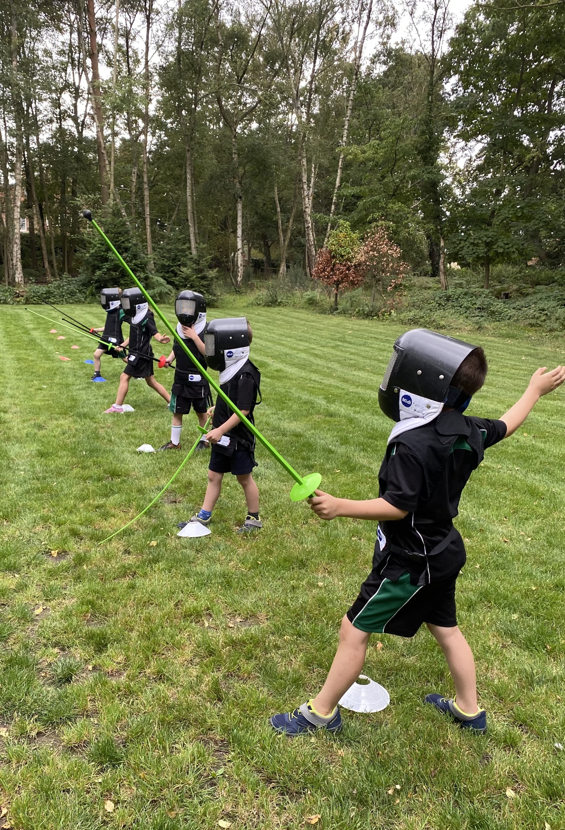
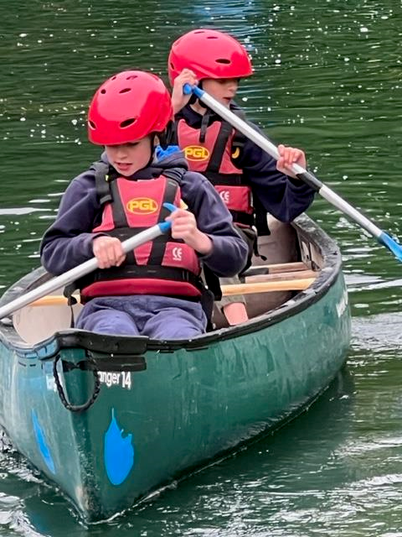
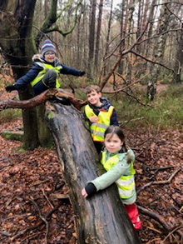
We run a range of clubs after school throughout the year. These have included; Lego, Forest School, animation, cross country, football, tag rugby, knitting and gardening.
We regularly ask children what kind of clubs they want and we are always looking to offer more fun and exciting opportunities.

Welcome to Curridge Primary School

Personal development is at the heart of the school. Adults provide pupils with leadership opportunities which deepens their understanding about democracy. This is through the school parliament where roles include, prime minister, minister of well-being, art, and the environment. Through these leadership positions, pupils play a tangible role in contributing to their school
community. Ofsted 2023

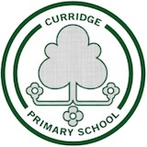

Behaviour across the school is positive. Playtimes are joyful environments where pupils show kindness and care to each other and adults. They value and take care of the equipment that leaders have provided for them and share it well with each other. Pupils are considerate and polite in their conduct around the school. They know how to behave because adults show them what this should look like. Ofsted 2023

Curridge Primary School
Thatcham
Berkshire
RG18 9DZ
01635 200486
office@curridge.w-berks.sch.uk

4.6 miles from Thatcham
4.9 miles from Newbury

We offer wraparound care from 8am—6pm

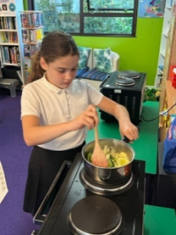
We value the opportunity to widen children’s horizons and enrich the curriculum by getting out into the wider community. We have visited:
The Natural History Museum, The Houses of Parliament, Westminster Abbey, Cotswold Wildlife Park, Kew Gardens, Cadbury’s World and the seaside.

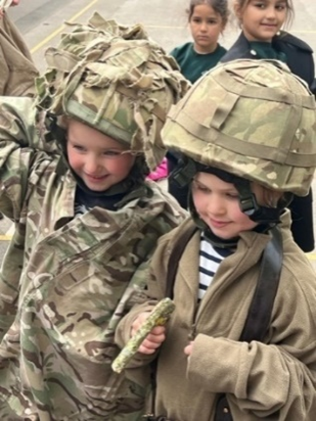
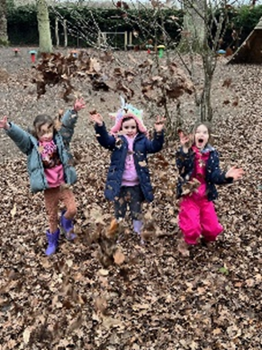
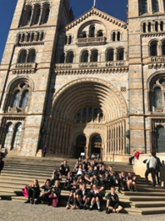
Our curriculum is rich, varied and full of opportunities to explore, acquire key knowledge and develop understanding and skills
We give every child the opportunity to shine in and out of the classroom.
Every child learns to read, write and speak French
All children, Y2-Y6, learn to play the
ukulele. They have a weekly music lesson
from an experienced musician
All children, from Y2-Y6, take part in a
weekly rock and pop choir session which is
led by an experienced singing teacher
Children are familiar with four different
Shakespeare plays by the end of their time
at primary school
Children visit laboratories to work
scientifically
Children compete in a range of sporting
activities with other local schools
Children try new sports such as fencing and
archery
Children cook using produce they have
Grown themselves
Work produced by children across the school
is exhibited each year in Newbury Museum

